**SQL PRETRAINING SESSION 3**

**V1: CUSTOMER RISK & VALUE SEGMENTATION  
FOUNDATIONS**

**Subtitle**: Advanced CASE Logic, Behavioral Profiling & Business Recommendations

**Context:** This pretraining document is part of the Skill AI Data Analyst Track.  
It focuses on advanced SQL techniques for customer scoring, segmentation, and portfolio risk classification in the EduFin loan crisis scenario. You’ll use complex CASE statements, nested aggregations, and multi-factor scoring models to transform raw demographic and loan data into actionable business intelligence.  
By the end, you’ll know how to identify high-value customers, flag high-risk profiles, and generate targeted business recommendations.

# TABLE OF CONTENTS

1. Session Overview
2. Learning Objectives
3. Part 1: Multi-Layered Risk Scoring
4. Part 2: Customer Segmentation with Business Rules
5. Part 3: Manual Pivot Operations
6. Part 4: Cohort Analysis Patterns
7. Part 5: Nested Aggregations & Ranking
8. Conclusion & Next Steps

# **1. SESSION OVERVIEW**

**Session Focus:**  
Advanced Business Analytics — “How do we score, segment, and monitor our customers for better decision-making?”

**Time Investment:**  
6–7 hours of focused learning

**Business Context:**  
EduFin’s leadership needs sharper insights into portfolio health, customer value, and operational risks.  
In this session, you’ll move beyond simple aggregation into **multi-dimensional analysis** — building weighted risk scores, segmenting customers using advanced rules, analyzing behavior over time, and validating data integrity.  
By combining business logic with SQL best practices, you’ll learn how to transform raw data into **actionable intelligence** for executives.

## **2. LEARNING OBJECTIVES**

You will master:

* ✅ Weighted scoring models using multiple business dimensions
* ✅ Complex CASE statements for multi-factor classification
* ✅ Advanced segmentation logic tied to income, job type, and loan history
* ✅ Manual cross-tabulation without the PIVOT function
* ✅ Cohort analysis for tracking customer behavior over time
* ✅ Nested aggregations and ranking within partitions
* ✅ Performance tuning techniques for large datasets
* ✅ Data quality validation patterns to ensure reliable analytics

# PART 1: MULTI-DIMENSIONAL ANALYSIS

## 1.1 Advanced GROUP BY Techniques

**Purpose:**  
To segment customers based on multiple attributes — such as **employment type** and **income bracket** — so that patterns can be detected for targeted interventions.

**Learning Goal:**  
You will learn how to:

* Apply **multi-level grouping**
* Use **CASE statements** inside GROUP BY
* Combine dimensions for **multi-attribute segmentation**

**-- Basic multi-dimensional grouping**

SELECT

c.employment_type,

CASE

WHEN c.annual_income < 500000 THEN 'Low Income'

WHEN c.annual_income < 1200000 THEN 'Medium Income'

ELSE 'High Income'

END AS income_segment,

COUNT(*) AS customer_count,

ROUND(AVG(c.annual_income), 2) AS avg_income,

MIN(l.application_date) AS first_customer,

MAX(l.application_date) AS latest_customer

FROM customers c

LEFT JOIN loans l

ON c.customer_id = l.customer_id

WHERE c.annual_income IS NOT NULL

GROUP BY

c.employment_type,

CASE

WHEN c.annual_income < 500000 THEN 'Low Income'

WHEN c.annual_income < 1200000 THEN 'Medium Income'

ELSE 'High Income'

END

ORDER BY customer_count DESC;

Output:

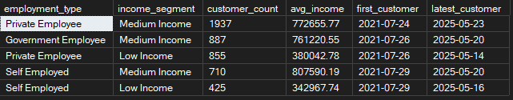

**-- Advanced multi-table segmentation**

SELECT TOP 5

c.employment_type,

CASE

WHEN c.annual_income < 500000 THEN 'Low Income'

WHEN c.annual_income < 1200000 THEN 'Medium Income'

ELSE 'High Income'

END AS income_segment,

dc.tier_classification AS city_tier,

COUNT(DISTINCT c.customer_id) AS unique_customers,

COUNT(l.loan_id) AS total_loans,

ROUND(AVG(l.loan_amount), 2) AS avg_loan_amount,

SUM(l.loan_amount) AS total_portfolio

FROM customers c

JOIN dim_city dc

ON c.city_id = dc.city_id

LEFT JOIN loans l

ON c.customer_id = l.customer_id

AND l.disbursement_date IS NOT NULL

GROUP BY

c.employment_type,

CASE

WHEN c.annual_income < 500000 THEN 'Low Income'

WHEN c.annual_income < 1200000 THEN 'Medium Income'

ELSE 'High Income'

END,

dc.tier_classification

HAVING COUNT(DISTINCT c.customer_id) >= 5

ORDER BY total_portfolio DESC;

Output:

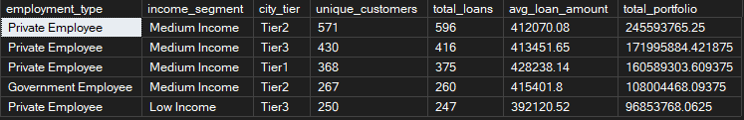

# PART 2: STATISTICAL ANALYSIS FUNCTIONS

## 2.1 Percentiles and Distribution Analysis

**Purpose:**  
To understand the distribution of customer and loan characteristics across different segments, identify outliers, and detect performance patterns for targeted decision-making.

**Learning Goal:**  
You will learn how to:

* Use percentile functions (PERCENTILE_CONT) to compute quartiles and medians
* Combine window functions with PARTITION BY for segmented statistics
* Compare distributions across employment types and income brackets
* Detect potential outliers using min, max, and standard deviation metrics

**-- Income distribution analysis by employment type**

SELECT DISTINCT

employment_type,

COUNT(*) OVER (PARTITION BY employment_type) AS customer_count,

MIN(annual_income) OVER (PARTITION BY employment_type) AS min_income,

PERCENTILE_CONT(0.25) WITHIN GROUP (ORDER BY annual_income)

OVER (PARTITION BY employment_type) AS income_25th_percentile,

PERCENTILE_CONT(0.5) WITHIN GROUP (ORDER BY annual_income)

OVER (PARTITION BY employment_type) AS median_income,

ROUND(AVG(annual_income) OVER (PARTITION BY employment_type), 2) AS mean_income,

PERCENTILE_CONT(0.75) WITHIN GROUP (ORDER BY annual_income)

OVER (PARTITION BY employment_type) AS income_75th_percentile,

MAX(annual_income) OVER (PARTITION BY employment_type) AS max_income,

STDEV(annual_income) OVER (PARTITION BY employment_type) AS income_std_deviation

FROM customers

WHERE annual_income IS NOT NULL

ORDER BY median_income DESC;

**Output:**

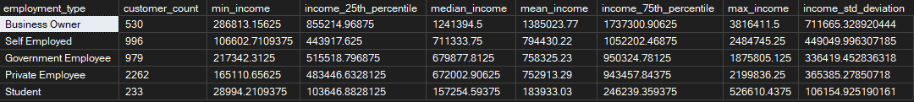

**-- Loan amount distribution by customer characteristics**

SELECT DISTINCT TOP 5

c.employment_type,

CASE

WHEN c.annual_income < 500000 THEN 'Low Income'

WHEN c.annual_income < 1200000 THEN 'Medium Income'

ELSE 'High Income'

END AS income_segment,

COUNT(l.loan_id) OVER (PARTITION BY c.employment_type,

CASE

WHEN c.annual_income < 500000 THEN 'Low Income'

WHEN c.annual_income < 1200000 THEN 'Medium Income'

ELSE 'High Income'

END) AS loan_count,

PERCENTILE_CONT(0.25) WITHIN GROUP (ORDER BY l.loan_amount)

OVER (PARTITION BY c.employment_type,

CASE

WHEN c.annual_income < 500000 THEN 'Low Income'

WHEN c.annual_income < 1200000 THEN 'Medium Income'

ELSE 'High Income'

END) AS loan_25th_percentile,

PERCENTILE_CONT(0.5) WITHIN GROUP (ORDER BY l.loan_amount)

OVER (PARTITION BY c.employment_type,

CASE

WHEN c.annual_income < 500000 THEN 'Low Income'

WHEN c.annual_income < 1200000 THEN 'Medium Income'

ELSE 'High Income'

END) AS median_loan,

AVG(l.loan_amount) OVER (PARTITION BY c.employment_type,

CASE

WHEN c.annual_income < 500000 THEN 'Low Income'

WHEN c.annual_income < 1200000 THEN 'Medium Income'

ELSE 'High Income'

END) AS mean_loan,

PERCENTILE_CONT(0.75) WITHIN GROUP (ORDER BY l.loan_amount)

OVER (PARTITION BY c.employment_type,

CASE

WHEN c.annual_income < 500000 THEN 'Low Income'

WHEN c.annual_income < 1200000 THEN 'Medium Income'

ELSE 'High Income'

END) AS loan_75th_percentile,

MAX(l.loan_amount) OVER (PARTITION BY c.employment_type,

CASE

WHEN c.annual_income < 500000 THEN 'Low Income'

WHEN c.annual_income < 1200000 THEN 'Medium Income'

ELSE 'High Income'

END) AS max_loan

FROM customers c

JOIN loans l

ON c.customer_id = l.customer_id

WHERE l.disbursement_date IS NOT NULL;

Output:

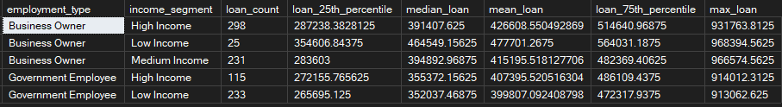

## 2.2 Variance and Risk Analysis

**Purpose:**To measure portfolio risk using statistical variance, classifying customer segments into stability tiers for better risk management.

**Learning Goal:**You will learn how to:

* Calculate standard deviation (STDEV) to assess portfolio volatility
* Create conditional classifications (High/Medium/Low variance)
* Group and segment data to isolate risky customer categories
* Apply HAVING clauses to ensure statistical relevance in analysis

**-- Customer portfolio risk analysis**

SELECT TOP 5

c.employment_type,

CASE

WHEN c.annual_income < 500000 THEN 'Low Income'

WHEN c.annual_income < 1200000 THEN 'Medium Income'

ELSE 'High Income'

END AS income_segment,

COUNT(DISTINCT c.customer_id) AS customers,

COUNT(l.loan_id) AS total_loans,

ROUND(AVG(l.loan_amount), 2) AS avg_loan_amount,

STDEV(l.loan_amount) AS loan_amount_stddev,

MIN(l.loan_amount) AS min_loan,

MAX(l.loan_amount) AS max_loan,

CASE

WHEN STDEV(l.loan_amount) > AVG(l.loan_amount) * 0.5

THEN 'HIGH VARIANCE - Unpredictable Segment'

WHEN STDEV(l.loan_amount) > AVG(l.loan_amount) * 0.25

THEN 'MEDIUM VARIANCE - Moderate Risk'

ELSE 'LOW VARIANCE - Stable Segment'

END AS risk_classification

FROM customers c

JOIN loans l

ON c.customer_id = l.customer_id

WHERE l.disbursement_date IS NOT NULL

GROUP BY

c.employment_type,

CASE

WHEN c.annual_income < 500000 THEN 'Low Income'

WHEN c.annual_income < 1200000 THEN 'Medium Income'

ELSE 'High Income'

END

HAVING COUNT(l.loan_id) >= 15

ORDER BY loan_amount_stddev DESC;

Output:

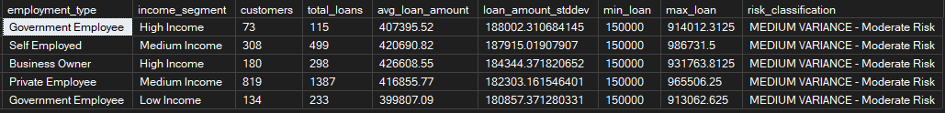

# PART 3: ADVANCED CASE STATEMENTS FOR CUSTOMER SCORING

## 3.1 Multi-Layered Risk Scoring

**Purpose:**  
To create comprehensive customer risk scores by combining multiple factors such as income, employment type, geographic classification, and tenure, enabling a more accurate assessment of creditworthiness.

**Learning Goal:**  
You will learn how to:

* Use multiple CASE statements to assign scores to different attributes
* Apply weighted scoring for composite risk assessment
* Incorporate aggregated values (e.g., tenure from earliest loan date) into scoring
* Classify customers into qualitative categories based on total scores

**-- Complex customer risk scoring**

SELECT TOP 5

c.customer_id,

c.full_name,

c.employment_type,

c.annual_income,

-- Income score (30% weight)

CASE

WHEN c.annual_income >= 1500000 THEN 30

WHEN c.annual_income >= 800000 THEN 25

WHEN c.annual_income >= 400000 THEN 20

WHEN c.annual_income >= 200000 THEN 15

ELSE 10

END AS income_score,

-- Employment score (25% weight)

CASE

WHEN c.employment_type = 'Government' THEN 25

WHEN c.employment_type = 'Private - MNC' THEN 23

WHEN c.employment_type = 'Private - Local' THEN 20

WHEN c.employment_type = 'Self Employed' THEN 15

ELSE 10

END AS employment_score,

-- Geographic score (20% weight)

CASE

WHEN dc.tier_classification = 'Tier1' THEN 15

WHEN dc.tier_classification = 'Tier2' THEN 12

ELSE 8

END AS geographic_score,

-- Tenure score (10% weight) - using loan disbursement date as proxy

CASE

WHEN DATEDIFF(YEAR, MIN(l.disbursement_date), GETDATE()) >= 3 THEN 10

WHEN DATEDIFF(YEAR, MIN(l.disbursement_date), GETDATE()) >= 1 THEN 8

ELSE 5

END AS tenure_score

FROM customers c

INNER JOIN dim_city dc ON c.city_id = dc.city_id

LEFT JOIN loans l ON c.customer_id = l.customer_id

WHERE c.annual_income IS NOT NULL

GROUP BY c.customer_id, c.full_name, c.employment_type, c.annual_income, dc.tier_classification;

**Output:**

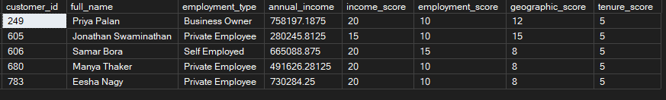

**-- Complete risk assessment with final scoring**

WITH customer_scores AS (

SELECT

c.customer_id,

c.full_name,

CASE

WHEN c.annual_income >= 1500000 THEN 30

WHEN c.annual_income >= 800000 THEN 25

WHEN c.annual_income >= 400000 THEN 20

WHEN c.annual_income >= 200000 THEN 15

ELSE 10

END AS income_score,

CASE

WHEN c.employment_type = 'Government' THEN 25

WHEN c.employment_type = 'Private - MNC' THEN 23

WHEN c.employment_type = 'Private - Local' THEN 20

WHEN c.employment_type = 'Self Employed' THEN 15

ELSE 10

END AS employment_score,

CASE

WHEN dc.tier_classification = 'Tier1' THEN 15

WHEN dc.tier_classification = 'Tier2' THEN 12

ELSE 8

END AS geographic_score,

CASE

WHEN DATEDIFF(YEAR, MIN(l.disbursement_date), GETDATE()) >= 3 THEN 10

WHEN DATEDIFF(YEAR, MIN(l.disbursement_date), GETDATE()) >= 1 THEN 8

ELSE 5

END AS tenure_score

FROM customers c

INNER JOIN dim_city dc ON c.city_id = dc.city_id

LEFT JOIN loans l ON c.customer_id = l.customer_id

WHERE c.annual_income IS NOT NULL

GROUP BY c.customer_id, c.full_name, c.annual_income, c.employment_type, dc.tier_classification

)

SELECT TOP 5

customer_id,

full_name,

(income_score + employment_score + geographic_score + tenure_score) AS total_score,

CASE

WHEN (income_score + employment_score + geographic_score + tenure_score) >= 75

THEN 'EXCELLENT - Prime Customer'

WHEN (income_score + employment_score + geographic_score + tenure_score) >= 60

THEN 'GOOD - Standard Approval'

WHEN (income_score + employment_score + geographic_score + tenure_score) >= 45

THEN 'FAIR - Enhanced Due Diligence'

ELSE 'POOR - High Risk Customer'

END AS risk_category

FROM customer_scores

ORDER BY total_score DESC;

Output:

## 3.2 Segmentation with Business Rules

**Purpose:**  
To define meaningful customer profiles based on income and employment combinations, enabling targeted strategies for acquisition, retention, and risk control.

**Learning Goal:**  
You will learn how to:

* Combine conditional logic with business-defined thresholds to create customer profiles
* Aggregate loan and default data for each segment
* Calculate portfolio metrics such as average income, loan count, portfolio size, and default rate
* Rank and compare segments based on performance indicators

**-- Advanced customer segmentation with business logic**

SELECT

customer_profile,

COUNT(*) AS customer_count,

AVG(annual_income) AS avg_income,

COUNT(total_loans) AS customers_with_loans,

AVG(total_loan_amount) AS avg_customer_portfolio,

COUNT(CASE WHEN has_default = 1 THEN 1 END) AS customers_with_defaults,

ROUND(

COUNT(CASE WHEN has_default = 1 THEN 1 END) * 100 / COUNT(*),

2

) AS default_rate_percent

FROM (

SELECT

c.customer_id,

c.annual_income,

COUNT(l.loan_id) AS total_loans,

SUM(l.loan_amount) AS total_loan_amount,

MAX(CASE WHEN l.loan_status = 'Defaulted' THEN 1 ELSE 0 END) AS has_default,

CASE

WHEN c.annual_income >= 1200000 AND c.employment_type = 'Government'

THEN 'Government High Earner'

WHEN c.annual_income >= 1200000 AND c.employment_type LIKE 'Private%'

THEN 'Private Sector Executive'

WHEN c.annual_income >= 1200000 AND c.employment_type = 'Self Employed'

THEN 'Successful Entrepreneur'

WHEN c.annual_income BETWEEN 500000 AND 1199999 AND c.employment_type = 'Government'

THEN 'Government Mid-Level'

WHEN c.annual_income BETWEEN 500000 AND 1199999 AND c.employment_type LIKE 'Private%'

THEN 'Private Sector Professional'

WHEN c.annual_income BETWEEN 500000 AND 1199999 AND c.employment_type = 'Self Employed'

THEN 'Growing Business Owner'

WHEN c.annual_income BETWEEN 200000 AND 499999

THEN 'Middle Income Earner'

ELSE 'Entry Level Professional'

END AS customer_profile

FROM customers c

LEFT JOIN loans l ON c.customer_id = l.customer_id AND l.disbursement_date IS NOT NULL

WHERE c.annual_income IS NOT NULL

GROUP BY c.customer_id, c.annual_income, c.employment_type

) customer_analysis

GROUP BY customer_profile

ORDER BY avg_customer_portfolio DESC;

Output:

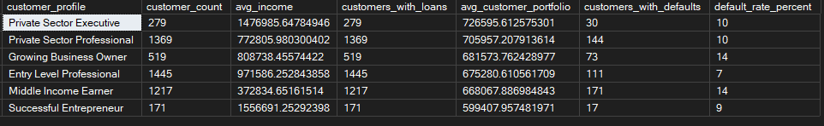

# PART 4: CROSS-TABULATION AND PIVOT ANALYSIS

## 4.1 Manual Pivot Operations

**Purpose:**  
To create cross-tabulation reports that summarize key metrics (such as income distribution by employment type) in a pivot-style format for decision-makers.

**Learning Goal:**  
You will learn how to:

* Use conditional aggregation (COUNT with CASE WHEN) to produce pivot-like summaries
* Group by categorical dimensions to display multiple metrics in one row
* Calculate percentage contributions within groups
* Rank categories based on total counts or proportions

**-- Employment type vs. Income bracket cross-tabulation**

SELECT

c.employment_type,

COUNT(CASE WHEN c.annual_income >= 1500000 THEN 1 END) AS High_Income_Count,

COUNT(CASE WHEN c.annual_income BETWEEN 1000000 AND 1499999 THEN 1 END) AS Upper_Middle_Count,

COUNT(CASE WHEN c.annual_income BETWEEN 600000 AND 999999 THEN 1 END) AS Middle_Count,

COUNT(CASE WHEN c.annual_income < 600000 THEN 1 END) AS Low_Income_Count,

COUNT(*) AS Total_Customers,

ROUND(COUNT(CASE WHEN c.annual_income >= 1500000 THEN 1 END) * 100 / COUNT(*), 1) AS High_Income_Percent

FROM customers c

WHERE c.annual_income IS NOT NULL

GROUP BY c.employment_type

ORDER BY Total_Customers DESC;

Output:

## 4.2 Cohort Analysis Patterns

**Purpose:**  
To track and compare customer performance over time by grouping them into cohorts based on their first activity, helping identify behavioral trends and risk patterns.

**Learning Goal:**  
You will learn how to:

* Use date functions to assign customers to cohorts by year and quarter
* Aggregate cohort-level loan and default statistics
* Calculate cohort default rates and assess risk categories
* Apply filtering to focus on statistically significant cohorts

**-- Customer first-loan cohort analysis**

WITH registration_cohorts AS (

SELECT

c.customer_id,

c.full_name,

c.employment_type,

c.annual_income,

MIN(l.disbursement_date) AS first_activity_date,

YEAR(MIN(l.disbursement_date)) AS registration_year,

CONCAT('Q', CEILING(MONTH(MIN(l.disbursement_date))/3.0), '-', YEAR(MIN(l.disbursement_date))) AS registration_quarter

FROM customers c

LEFT JOIN loans l ON c.customer_id = l.customer_id

WHERE c.annual_income IS NOT NULL

GROUP BY c.customer_id, c.full_name, c.employment_type, c.annual_income

),

cohort_loan_behavior AS (

SELECT

rc.registration_quarter,

rc.employment_type,

COUNT(DISTINCT rc.customer_id) AS cohort_customers,

COUNT(l.loan_id) AS total_loans,

AVG(l.loan_amount) AS avg_loan_amount,

COUNT(CASE WHEN l.loan_status = 'Defaulted' THEN 1 END) AS defaults,

ROUND(

COUNT(CASE WHEN l.loan_status = 'Defaulted' THEN 1 END) * 100/ NULLIF(COUNT(l.loan_id), 0),

2

) AS cohort_default_rate

FROM registration_cohorts rc

LEFT JOIN loans l ON rc.customer_id = l.customer_id AND l.disbursement_date IS NOT NULL

GROUP BY rc.registration_quarter, rc.employment_type

)

SELECT TOP 5

registration_quarter,

employment_type,

cohort_customers,

total_loans,

ROUND(avg_loan_amount, 0) AS avg_loan_formatted,

defaults,

COALESCE(cohort_default_rate, 0) AS default_rate,

CASE

WHEN COALESCE(cohort_default_rate, 0) > 15 THEN 'HIGH RISK COHORT'

WHEN COALESCE(cohort_default_rate, 0) > 8 THEN 'MEDIUM RISK COHORT'

WHEN total_loans > 0 THEN 'LOW RISK COHORT'

ELSE 'NO LOAN ACTIVITY'

END AS cohort_risk_assessment

FROM cohort_loan_behavior

WHERE cohort_customers >= 5

ORDER BY registration_quarter DESC, employment_type;

Output:

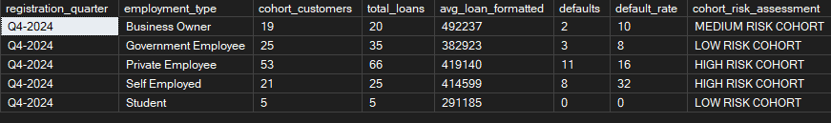

# PART 5: ADVANCED AGGREGATION PATTERNS

## 5.1 Nested Aggregations

**Purpose:**  
To generate deeper business insights by aggregating already aggregated results, allowing for advanced portfolio and segment-level analysis.

**Learning Goal:**  
You will learn how to:

* Create multi-step aggregations using Common Table Expressions (CTEs)
* Summarize individual customer metrics into segment-level statistics
* Calculate segment penetration, high-value customer counts, and default rates
* Apply classification logic to group segments by performance and risk

**-- Customer portfolio concentration analysis**

WITH customer_portfolios AS (

SELECT

c.customer_id,

c.employment_type,

c.annual_income,

COUNT(l.loan_id) AS loan_count,

SUM(l.loan_amount) AS total_borrowed,

AVG(l.loan_amount) AS avg_loan_size,

MAX(CASE WHEN l.loan_status = 'Defaulted' THEN 1 ELSE 0 END) AS has_default

FROM customers c

LEFT JOIN loans l

ON c.customer_id = l.customer_id

AND l.disbursement_date IS NOT NULL

WHERE c.annual_income IS NOT NULL

GROUP BY c.customer_id, c.employment_type, c.annual_income

),

portfolio_segments AS (

SELECT

employment_type,

COUNT(*) AS customers_in_segment,

COUNT(CASE WHEN loan_count > 0 THEN 1 END) AS customers_with_loans,

AVG(COALESCE(total_borrowed, 0)) AS avg_customer_portfolio,

AVG(COALESCE(loan_count, 0)) AS avg_loans_per_customer,

COUNT(CASE WHEN has_default = 1 THEN 1 END) AS customers_with_defaults,

COUNT(CASE WHEN total_borrowed > 2000000 THEN 1 END) AS high_value_customers,

COUNT(CASE WHEN loan_count >= 3 THEN 1 END) AS multi_loan_customers

FROM customer_portfolios

GROUP BY employment_type

)

SELECT

employment_type,

customers_in_segment,

customers_with_loans,

ROUND(avg_customer_portfolio, 0) AS avg_portfolio_formatted,

ROUND(avg_loans_per_customer, 2) AS avg_loans_per_customer,

customers_with_defaults,

ROUND(customers_with_defaults * 100 / NULLIF(customers_with_loans, 0), 2) AS segment_default_rate,

high_value_customers,

multi_loan_customers,

ROUND(customers_with_loans * 100/ customers_in_segment, 1) AS loan_penetration_rate,

CASE

WHEN customers_with_defaults * 100.0 / NULLIF(customers_with_loans, 0) > 20

THEN 'HIGH RISK SEGMENT'

WHEN avg_customer_portfolio > 1500000 AND customers_with_defaults * 100.0 / NULLIF(customers_with_loans, 0) < 5

THEN 'PREMIUM SEGMENT'

WHEN customers_with_loans * 100.0 / customers_in_segment > 80

THEN 'HIGH ENGAGEMENT SEGMENT'

ELSE 'STANDARD SEGMENT'

END AS segment_classification

FROM portfolio_segments

WHERE customers_in_segment >= 10

ORDER BY avg_customer_portfolio DESC;

Output:



## 5.2 Ranking and Percentile Analysis

**Purpose:**  
To identify top and bottom performers within defined groups, supporting prioritization for engagement, rewards, or risk control.

**Learning Goal:**  
You will learn how to:

* Rank customers within categories using ROW_NUMBER and NTILE
* Calculate deciles for relative positioning
* Combine performance metrics into composite scoring
* Apply classification rules to label customers by value or risk level

**-- Customer ranking within employment type**

WITH customer_metrics AS (

SELECT

c.customer_id,

c.full_name,

c.employment_type,

c.annual_income,

dc.tier_classification,

COUNT(l.loan_id) AS loan_count,

SUM(l.loan_amount) AS total_portfolio,

COUNT(CASE WHEN l.loan_status = 'Defaulted' THEN 1 END) AS default_count,

CASE

WHEN COUNT(l.loan_id) = 0 THEN 0

ELSE SUM(l.loan_amount) * (1 - COUNT(CASE WHEN l.loan_status = 'Defaulted' THEN 1 END) * 1.0 / COUNT(l.loan_id))

END AS customer_value_score

FROM customers c

INNER JOIN dim_city dc ON c.city_id = dc.city_id

LEFT JOIN loans l

ON c.customer_id = l.customer_id

AND l.disbursement_date IS NOT NULL

WHERE c.annual_income IS NOT NULL

GROUP BY c.customer_id, c.full_name, c.employment_type, c.annual_income, dc.tier_classification

)

SELECT

customer_id,

full_name,

employment_type,

ROUND(annual_income, 0) AS income_formatted,

tier_classification,

loan_count,

ROUND(total_portfolio, 0) AS portfolio_formatted,

default_count,

ROUND(customer_value_score, 0) AS value_score,

ROW_NUMBER() OVER (PARTITION BY employment_type ORDER BY customer_value_score DESC) AS rank_in_employment_type,

NTILE(10) OVER (PARTITION BY employment_type ORDER BY customer_value_score DESC) AS segment_decile,

ROW_NUMBER() OVER (ORDER BY customer_value_score DESC) AS overall_rank,

CASE

WHEN customer_value_score > 5000000 THEN 'VIP CUSTOMER'

WHEN customer_value_score > 2000000 THEN 'HIGH VALUE CUSTOMER'

WHEN customer_value_score > 500000 THEN 'STANDARD CUSTOMER'

WHEN loan_count > 0 THEN 'DEVELOPING CUSTOMER'

ELSE 'PROSPECT'

END AS customer_classification

FROM customer_metrics

WHERE customer_value_score > 0

ORDER BY customer_value_score DESC;

Output:



© 2025 Skill AI Path. All Rights Reserved.  
Licensed for educational and internal business use.  
Attribution required when sharing. Commercial redistribution prohibited.

Contact Us - [tech@skillaipath.com](mailto:tech@skillaipath.com) | [skillaipath.com](http://skillaipath.com/)